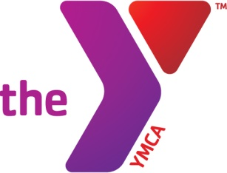

CIRCLE LOCATION: John Rex Charter School

FEE: $10 per child (Each additional child will be $5)

Child’s Name Age Gender M / F

Child’s Name Age Gender M / F

Child’s Name Age Gender M / F

Parent’s Name

Address City Zip

Phone Numbers

Emergency Contact other than Parent/ Guardian

Address City Zip

Phone Numbers

Additional Persons Authorized to Pick Up My Child

I

authorize the YMCA to release my child to the following persons when I am unavailable. I understand that I must inform the YMCA of any changes to the list. They must show photo ID.

Name Address Phone # Relationship

 List any know allergies (such as food/ drug) or special needs we should know about:

Hold Harmless Agreement

By my signature, and of my free will, I do hereby agree to indemnify and hold harmless the YMCA of Greater Oklahoma City from any and all claims or demands, costs, or expense arising out of any injuries, damages, or other losses, whether personal or property, sustained be me or any party to whom I am responsible.

Parent/Guardian Signature Date

VOTER’S NIGHT OUT!

November 8th,6:00PM-8:00PM